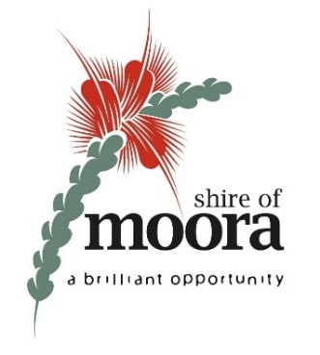

SHIRE OF MOORA
SPECIAL COUNCIL MEETING MINUTES
9 JANUARY 2026

TABLE OF CONTENTS
1. DECLARATION OF OPENING 2
2. ATTENDANCE / APOLOGIES / APPROVED LEAVE OF ABSENCE 2
3. DECLARATIONS OF INTEREST 2
4. APPOINTMENT OF ACTING CHIEF EXECUTIVE OFFICER – CONFIDENTIAL ITEM 2
5. CLOSURE OF MEETING 3

- DECLARATION OF OPENING

The Shire President declared the meeting open at 4.00 pm.

Acknowledgement of Country

The Shire of Moora acknowledges the traditional custodians of the land we are meeting on, the Yued people, and pay our respects to Elders past, present, and emerging.

- ATTENDANCE / APOLOGIES / APPROVED LEAVE OF ABSENCE

ATTENDEES

Councillors
KM Seymour - President
EI Hamilton - Deputy President
DV Clydesdale-Gebert - Councillor
TW Dugan - Councillor (via Teams)
SJ Gilbert - Councillor
M James - Councillor
AJ Phillips - Councillor

Staff
B Hoogland - Deputy Chief Executive Officer
N Ugarte - Executive Manager, Corporate Services, Governance
and Policy

APOLOGIES

GW Robins - Chief Executive Officer

APPROVED LEAVE OF ABSENCE

Nil.
- DECLARATIONS OF INTEREST

Nil.
- APPOINTMENT OF ACTING CHIEF EXECUTIVE OFFICER – CONFIDENTIAL ITEM

COUNCIL RESOLUTION (OFFICER RECOMMENDATION)

1/26 Moved Cr Hamilton, seconded Cr Phillips, that Council close the meeting to the public at 4.03 pm to consider the appointment of an Acting Chief Executive Officer, in accordance with section 5.23(2) of the Local Government Act 1995.

CARRIED: 7/0

For: Crs Seymour, Hamilton, Clydesdale-Gebert, Dugan, Gilbert, James and Phillips.
Against: Nil.

COUNCIL RESOLUTION (OFFICER RECOMMENDATION)

2/26 Moved Cr Gilbert, seconded Cr Clydesdale-Gebert, that Council open the meeting to the public at 4.54 pm.

CARRIED: 7/0

For: Crs Seymour, Hamilton, Clydesdale-Gebert, Dugan, Gilbert, James and Phillips.
Against: Nil.

COUNCIL RESOLUTION (OFFICER RECOMMENDATION)

3/26 Moved Cr Gilbert, seconded Cr Hamilton, that Council appoint Mr Maurice Battilana as Acting Chief Executive Officer of the Shire of Moora for the period commencing on 12 January 2026 and ending on 27 February 2026 (inclusive).

CARRIED: 4/3

For: Crs Seymour, Hamilton, Gilbert and Phillips.
Against: Crs Clydesdale-Gebert, Dugan and James.

CLOSURE OF MEETING

The Shire President declared the meeting closed at 4.56 pm.

